

STANDARD OPERATING PROCEDURE

Diagnostic Semen Analysis & Post Vasectomy Analysis

PRINTED COPIES OF THIS DOCUMENT ARE UNCONTROLLED
PLEASE REFER TO Q PULSE FOR THE LATEST VERSION

DOCUMENT DETAILS
AUTHOR (NAME & JOB ROLE): |  |  | Lyndsey Zujovic, Group Director of Embryology
DOCUMENT APPLICABLE TO: |  |  | TFP GROUP (UK ONLY)
DISTRIBUTION GROUP: |  |  | All Laboratory Staff
AMMENDMENT HISTORY
REVISION | ACTIVE DATE | CHANGES MADE
1.0 | 28/01/2020 | Initial release.
2.0  3.0  4.0  5.0 | 13/02/2020  20/05/2021  02/02/2022  09/02/2023 | For pH test, semen must be added to the pH paper (pH paper not dipped in the sample)  Haemocytometer cover slip specification added  Updated with reference to WHO 2021 6th edition. Samples produced off site must be delivered to clinic within 50 minutes of production. Requirement to clean men’s room prior to use added.  Revised method for concentration assessment, counting squares instead of rows. Revised reference values added and acceptable difference tables updated for motility and concentration. Worked example added for motility calculations. Images of LeucoScreen Plus and vitality assessments added. Option of using 20ml Potassium Citrate mixture to equilibrate pH for retrograde analysis added.  Updated section 5.9. Removed method for ‘Sperminator’ CASA and replaced with SCA CASA method. Cellvision slides replaced with Leja slides for use with the SCA CASA system.

Purpose
To describe the procedure for analysing semen parameters and post vasectomy analysis to required standards as set out in WHO (2021), ABA Guidelines for good Practice (2012) and Guidelines for Post Vasectomy analysis (2016). Semen samples can be analysed for patients prior to coming through for fertility treatment to determine the likely treatment type, for prospective sperm donors to determine their suitability or for patients undergoing fertility assessment via a GP or privately. Post vasectomy analysis is carried out for patients following vasectomy to assess the sample for the presence of sperm.

Scope
Applicable to all embryologists, andrologists and practitioners deemed competent to perform semen analysis:

Definitions
PPE Personal Protective Equipment
IUI Intra Uterine Insemination
IVF In Vitro Fertilisation
ICSI Intra Cytoplasmic Sperm Injection
HPF High Power Field
MEA Mouse Embryo Assay
SSR Surgical Sperm Retrieval
WHO World Health Organisation

Responsibilities
            - General Manager
The General Manager (GM) is accountable for the implementation of this clinic-wide process.
            - Laboratory Lead
The Laboratory Lead is responsible for ensuring that current practice is in line with this SOP, all staff have been trained appropriately and signed off competent to enable them to work safely and ensure patient’s safety at all times. The Laboratory Lead is also responsible for ensuring that all non-compliance with this SOP or incidents occurring are properly investigated and any corrective action taken. They are also responsible for auditing compliance to this SOP.
            - Quality Manager
The Quality Manager is responsible for ensuring that all staff are aware of and comply with the requirements specified in this document. The QM is also responsible for ensuring all non-compliance with this SOP, or incidents occurring are properly investigated and any corrective action taken is recorded on QPulse.
            - All Staff
Are responsible for following the process laid out in this document, ensure they receive up-to-date training to enable safe working and to request further training if they feel it is required. Staff are also responsible for reporting any non-compliance or incidents occurring on QPulse and following up the outcome of any reported incidents/non-conformities.

Procedure

5.1 Equipment & Consumables Required
Equipment/Consumables Required
- Serological pipettes
- Pipette Boy (or similar)
- Gilson/Eppendorf Pipette & tips (or similar)
- Glass Slides & Cover slips (22mm x 22mm #1.5 weight)
- Positive Displacement Pipette & tips
- Improved Neubauer Haemocytometer
- Haemocytometer Cover Slip Grade #4 0.44m
- pH strips (pH 6.0-10.0)
- Pre-stained Morphology Slides
- Vortex Mixer
- Weighing scales
- Microscope heated stage (optional)
- Cell Counter
- Stop Watch
- Damp Box
- Gloves
- Clinical waste & sharps bins
- Plastic Pasteur pipettes(optional)
- Non-Toxic Condom (optional)
- PVSA Deep chamber slides (100um) (optional)
- Leja slides 2 chambers for CASA (optional)

Tubes/Pots/Media Required
- Sperm Production Pot
- Anti-Sperm antibodies (IgG, IgA optional)
- Eppendorf Tubes
- Conical Tubes (optional)
- Vitalscreen
- HOS Test
- LeucoScreen Plus
- Media for Dilution GIVF⁺/GMOPS⁺

5.2 Equipment Checks
Prior to performing the semen analysis procedure, the equipment to be used must be checked to ensure it is operating optimally.
The flowhood (if applicable) must be checked to ensure the flow is on and the hood is clear of used pots/pipettes and tubes.
Ensure the microscope heated stage (if applicable) is switched on and set at 37°C at least 10 minutes prior to examination of samples.

5.3 Witnessing Checks (Full Name, Clinic Number & D.O.B.)
There should be a minimum of 3 patient identifiers on the sample pot e.g. full name, D.O.B. & clinic number.
Ask the patient to state their full name and D.O.B. Check this information along with their clinic or hospital number matches the patient’s laboratory record and sample pot. Record the number of day’s abstinence and any illness/medication in the last 2-3 months. The above checks must be performed whether the sample is produced on-site or off-site.
For on-site production, hand the patient the sample pot and provide the patient with sample production instructions. Instruct the patient to inform the laboratory team if not all the sample is collected/or record this on the sample production form.

5.3.1 Post Vasectomy Analysis Rejection Criteria
Samples that are incorrectly labelled, unlabelled, where the witnessing step has not been fully completed or whereby there is doubt as to its identification must be rejected.
For post vasectomy samples it is imperative that the patient confirms whether the whole sample has been collected or not. This can be recorded on the sample production form or be confirmed verbally post-production as part of the sample hand-over procedure. This must be clearly documented in the laboratory notes. Incomplete samples for post vasectomy analysis must be rejected and a further appointment made for the patient.
See section 5.12 for the strict criteria that must be met for clearance to be given.

5.3.2 Diagnostic Semen Analysis Rejection Criteria
Samples that are incorrectly labelled, unlabelled, where the witnessing step has not been fully completed or whereby there is doubt as to its identification, must be rejected.
Samples for diagnostic semen analysis may still be analysed in the following scenarios, however, a note should be made on the report and the patient must be made aware that they may need a repeat analysis if there are any abnormal parameters.
- Patient has not adhered to correct abstinence period
- Patient has had any illness/medication known to affect sperm quality
- Patient has not collected a complete sample (except for Post vasectomy analysis, which must be rejected)
- Patient has not delivered the sample to the unit within 50 minutes of production or has not maintained the correct temperature of the sample during transport to the lab (if producing off site).

Once the sample has been produced, transfer the sample to the flowhood/laboratory bench or warming oven if available.
Only one sample may be processed in a flowhood at any one time.

5.4 Sample Production
Semen analysis should be performed following 2-7 days abstinence.
Semen samples should where possible be produced on site in order to limit temperature variations and control time between collection and analysis.
Semen samples should be collected via masturbation into pre-weighed, labelled, plastic containers which are clean, wide-mouthed and that have ideally been confirmed to be non-toxic to sperm.
If the patient is to produce on site, the sample production room must be cleaned prior to use by wiping all surfaces (including door handles, the sample production hatch, chairs, pens etc.) in the production room using alcohol free disinfectant wipes or Oosafe.
If the patient is unable to produce on site, offer the patient the option to produce off site. Provide the patient with a pre-weighed and pre-labelled sample pot. If the sample is produced off-site the patient must sign an off-site production declaration stating that the sample is his own and has not been tampered with. Advise the patient to keep the sample around body temperature and to bring it to the clinic within 50 minutes of production.
Patients may also be given the option of producing the sample into a non-toxic condom.

5.5 Preparation for the Procedure
Turn on the heated stage and set to 37°C for at least 10 minutes prior to use.
Remove reagents from the fridge and allow them to warm to room temperature prior to use.
Pre-weigh the labelled sample pot prior to the patient producing the sample, note the weight of the empty pot on the lid.

5.6 Timing of Semen Analysis
Begin initial analysis of the semen sample 15-60 minutes post-production and following sample liquefication.
If after 30 minutes the sample fails to liquefy, place the sample on to a heated stage/warming oven set at 37°C, and re-assess after 30 minutes (with repeated pipetting). If after 60 minutes the sample is still not liquefied, an equal volume of pre-equilibrated media may be added, however this must be reported and accounted for when calculating sperm concentration.
Delay or failure of the sample to liquefy after 30 or 60 minutes should be noted on the final report.

5.7 Semen Analysis
This section is the main text of the SOP. It details the procedure for the task to be performed.
Assess the volume, viscosity, concentration, motility, morphology, pH and presence of anti-sperm antibodies of the initial semen sample.
Assessments of round cells and viability are performed depending on the patient’s clinical history and/or sample characteristics.
Gloves must be worn when handling human semen.

5.7.1 Assessment of Sample Volume (Reference value ≥1.4ml)
The sample pot must be pre-weighed and the weight recorded. Once the patient has produced the sample, weigh the pot containing the semen sample and note the weight.
To calculate the sample volume, subtract the weight of the empty sample pot from the weight of the pot + sample. Calculate the sample volume assuming the density of semen to be 1g/ml.

5.7.2 Initial Macroscopic Assessment of Viscosity and Appearance
Prior to analysis the sample should be mixed by either manually swirling for 15-30 seconds or by using a serological/Pasteur pipette and thoroughly mixing the sample by pipetting up and down several times.
Assess the viscosity by allowing semen to drop by gravity from a serological pipette and observing the length of the thread. A thread of >2 cm indicates abnormal viscosity. Record the sample viscosity as ‘viscous’ or ‘non-viscous’.
Any abnormal appearance should be recorded, for example a pinkish colour may indicate blood is present.
For samples that are extremely viscous and where assessment may be difficult, the sample should be treated as above for delayed liquefaction prior to analysis.

5.7.3 Assessment of Motility (Reference value A + B= ≥30%)
Perform motility assessment within 60 minutes of sample production, and ideally within 30 minutes following liquefaction. Perform the motility assessment on a heated stage at 37°C where possible.
Mix the sample and then place 10 µl of semen onto a clear glass slide and cover with a glass cover slip.
Re-mix the sample and place a replicate 10µl drop of semen on to a glass slide and cover with a glass coverslip.
Observe the slides at X200-400 magnification. Avoiding areas that are close to the edge of the coverslip, grade the motility of 200 sperm per replicate in a minimum of 5 randomly chosen fields using the following criteria:
Grade A – rapid progressive motility (≥25µm/s)
Grade B – slow or sluggish motility (5 - <25 µm/s)
Grade C – non-progressive motility (<5 µm/s)
Grade D – immotile (no active tail movement)
Note: If 200 sperm have been counted in one replicate before all grades have been scored, continue counting until all grades have been scored on that field.
Calculate the percentages of each grade, and then calculate the percentage of total progressive motile.
Assess if there is an acceptable difference between the 2 replicate values for the most frequent grade of motility noted (motile or immotile), by referring to the table below (based on 95% confidence interval).

Table 1: Acceptable differences for motility assessment for the most ‘frequent’ grade
Average (%) | Acceptable Difference
1 | 2
2-3 | 3
4-6 | 4
7-9 | 5
10-13 | 6
14-19 | 7
20-27 | 8
28-44 | 9
45-55 | 10
Average  (%) | Acceptable Difference
56-72 | 9
73-80 | 8
81-86 | 7
87-90 | 6
91-93 | 5
94-96 | 4
97-98 | 3
99 | 2

If the difference between the percentages is acceptable, report the average percentage of each grade. If the difference is not acceptable make two new replicate slides and repeat the process. If the difference is still not acceptable following 2 further repeat assessments, then the average of all six assessments should be used to calculate the motility of each grade with a note on the report regarding the uncertainty of the result due to high variability.
Note the results as a percentage of each grade.
Worked example:
In replicate one: 200 sperm are counted to give the following motility grades (%):

Motility = 10/26/4/60 and a total progressive motility of 10 + 26 = 36%

In replicate two: 210 sperm are counted and converted to percentages to give:

Motility = 8/26/3/63 and a total progressive motility of 8 + 26 = 34%

The most frequent grade for both replicates above (motile or immotile) is the immotile grade D (60 & 63) therefore the average and difference between the two replicates is calculated for this grade (and rounded up to a whole number):

Average = 60 + 63 /2 = 61.5 = 62
Difference = 63-60 = 3

By referring to table 1 this difference (3) is seen to be less than that found by chance alone for the calculated average of 62 (acceptable difference = 9), so the values are accepted.

The averages between the two motilities are therefore calculated and reported. Note these must be reported in whole numbers therefore any grades that are not whole numbers must be rounded up for the dominant grade i.e. 61.5 must be rounded up to 62, or down for non-dominant grades:
Average = a’s = (10+8)/2, b’s = (26 + 26)/2, c’s = (4+3)/2 and d’s = (60+63)/2
Average motility = 9/26/3.5/61.5

Therefore reported motility = 9/26/3/62

5.7.4 Assessment of Concentration (Reference value ≥16M/ml)
Assess the appropriate dilution to be used according to the number of sperm per HPF observed on a wet preparation at x400 in a minimum of 3 fields. A minimum volume of 50µl semen should be used to make up dilutions, and the total volume should be a minimum of 200 µl.
Table 2: Dilutions required for concentration assessment
Spermatozoa per x400 field | Dilution required | Semen  (µl) | Water  (µl)
>40 | 1:20 (1 + 19) | 50 | 950
16-40 | 1:10 (1+9) | 50 | 450
2-15 | 1:5 (1+4) | 50 | 200
<2 | 1:2 (1+1) | 100 | 100

Dilutions of the semen sample should be made immediately after mixing and within 60 minutes of sample production. Aliquots of water should be prepared the same day as used to prevent evaporation.
Attach the cover slip to the haemocytometer until Newtons Rings are visible. The cover slip must be a thickness of 0.44mm #4.
Prepare the first dilution using the dilutions described above, by pipetting the required volume of semen into in an Eppendorf tube containing the required volume of water/fixative. Ensure the pipette tip is rinsed via aspirating up and down a few times.
Vortex the diluted sample for 15 seconds at high speed to mix thoroughly, and immediately remove an aliquot of 8-10 µl. Gently pipette approximately 8-10µl of the first diluted sample onto one side of the haemocytometer chamber, allowing the chamber to fill by capillary action.
Prepare a second replicate dilution as above and immediately pipette approximately 8-10µl of the second dilution into the other side of the haemocytometer chamber.
Allow the chamber to settle for 4 minutes in a humid chamber before analysis. Observe the chamber at X200-400 magnification.
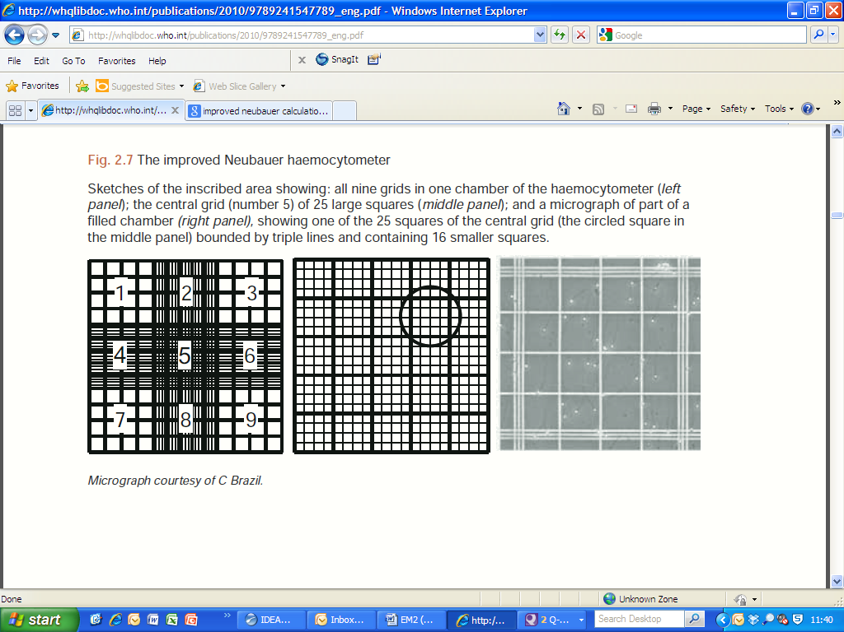
The Neubauer Haemocytometer Chamber
The central grid
Image 1: Haemocytometer chamber
The haemocytometer chamber consists of two sides. On each side of the chamber there are 9 grids (see image 1 above). The central grid (5 in image above) consists of 25 large squares, each of which is subdivided into 16 smaller squares as shown in image 2 below.
In the central grid each row consists of 5 large squares.
For each square, Spermatozoa should be counted if the head lies within the boundary of the square, indicated by the middle line of the three and if its head lies on the middle line on one of two perpendicular lines (i.e. the lower and left boundaries which form an “L shape”) see image 2 below.

Only count sperm if the head lies within the middle of the 3 lines and if it lies on the middle line on one or two of the perpendicular lines
A row of 5 squares in the central grid

Image 2: The Central Grid (5 in the image above)

A minimum of 200 sperm must be counted. Count only morphologically mature cells with tails.
When assessing the concentration 5,10, or 25 squares must always be counted even if a count of 200 sperm has already been reached, i.e. if 4 squares have been counted and 200 sperm have been reached, the 5th square must still be counted.
If a count of 200 sperm is not reached in the central grid, then the 2 grids adjacent should be counted (grids 4 and 6 in image 3 below):

Image 3 – Grids 4 and 6
The 2 grids (4 and 6) are again made up of 5 rows, however each row consists of 4 large squares.
If 200 sperm cannot be counted in grids 5,6 and 4 then a higher dilution factor should be used if possible. For very low concentrations using a 1:2 dilution all 9 grids may be assessed with the same principles as above. If 200 sperm cannot be counted using a 1:2 dilution in all 9 grids, a note should be made on the report that <200 sperm counted.
Counting procedure
Observe the central grid on one side of the haemocytometer.
Count a minimum of 5 squares in the central grid. If 200 sperm are counted record the number of sperm counted in the 5 squares.
If a minimum of 200 sperm are not observed in the first 5 squares, then continue counting to 10 squares in the central grid, and record the results.
If 200 sperm are not observed in the 10 squares then continue counting all 25 squares of the central grid and record the results.
If the whole of the central grid (25 squares) has been counted and 200 sperm have not been observed, either prepare new dilutions using the next dilution factor, if possible, or count the whole of one of the grids adjacent to the central grid (grids 4 or 6). Continue to count whole grids (grids 4,5,6,7,8,9) until a minimum of 200 sperm has been counted.
Once a minimum of 200 sperm have been counted make a note of the number of either squares or whole grids assessed to count 200 sperm and count the same number of squares/grids on the second side of the haemocytometer chamber.
Calculate the sum and difference of the two results. Determine the acceptability of the difference from the table below.

Table 3: Acceptable differences for concentration assessment
Sum | Acceptable Difference
44-51 | 13
52-58 | 14
59-66 | 15
67-75 | 16
76-84 | 17
85-93 | 18
94-104 | 19
105-114 | 20
115-125 | 21
126-137 | 22
138-149 | 23
150-162 | 24
163-175 | 25
176-189 | 26
190-205 | 27
206-218 | 28
219-234 | 29
235-250 | 30
251-266 | 31
267-283 | 32
284-300 | 33
301-318 | 34
Sum | Acceptable Difference
319-337 | 35
338-356 | 36
357-375 | 37
376-395 | 38
396-416 | 39
417-437 | 40
438-459 | 41
460-481 | 42
482-503 | 43
504-527 | 44
528-550 | 45
551-575 | 46
576-599 | 47
600-624 | 48
625-650 | 49
651-677 | 50
678-703 | 51
704-731 | 52
732-759 | 53
760-787 | 54
788-816 | 55
817-845 | 56

If the difference is too high, prepare a new haemocytometer chamber and repeat the process. If the difference is still not acceptable following 2 further repeat assessments, then the average of all six assessments should be used with a note on the report regarding the uncertainty of the result due to high variability.
If the difference is acceptable, calculate the concentration by dividing the total number of sperm counted by a correction factor (as shown in the table below) determined by the dilution used and the total number of squares or grids counted.
Table 4: Correction factors for calculating concentrations
 | No. of squares counted in each chamber |  |  | No. of grids counted in each chamber
Dilution | 5 | 10 | 25 | 2 | 3 | 4 | 5 | 6 | 7 | 8 | 9
 | Correction factor values
1:2 | 20 | 40 | 100 | 200 | 300 | 400 | 500 | 600 | 700 | 800 | 900
1:5 | 8 | 16 | 40 | 80 | 120 | 160 | 200 | 240 | 280 | 320 | 360
1:10 | 4 | 8 | 20 | 40 | 60 | 80 | 100 | 120 | 140 | 160 | 180
1:20 | 2 | 4 | 10 | 20 | 30 | 40 | 50 | 60 | 70 | 80 | 90
1:50 | 0.8 | 1.6 | 4 | 8 | 12 | 16 | 20 | 24 | 28 | 32 | 36
For example if using a 1:20 dilution 5 squares are counted = Total sperm counted / 2 = M/ml
If using a 1:10 diltuion 5 squares in each chamber = Total sperm counted / 4 = M/ml
For samples where 200 sperm cannot be counted in all 9 nine grids, the result is reported, however a note should be made on the report that <200 sperm counted and the increased error of >5% associated with this.
For samples where an accurate concentration assessment is not possible and estimated error is high (<25 sperm in each whole chamber using a 1:2 dilution i.e. <55,555 sperm/ml), the number of sperm observed on the chamber should be reported, and a note on the report that too few sperm seen for accurate assessment (<56,000).

Worked examples
- Example 1 – a 1:20 dilution factor used (950µl water :50µl semen)
In replicate one, 220 spermatozoa in 10 squares are counted, while replicate two contains 218 in 10 squares. The sum of the values (220 + 218) is 438 in 20 squares and the difference between the two replicates (220-218) is 2. This is seen to be less than that found by chance alone (acceptable difference = 41), so the values are accepted.
From table 4 above the correction factor for a 1:20 dilution and 10 squares counted in each chamber is 4.
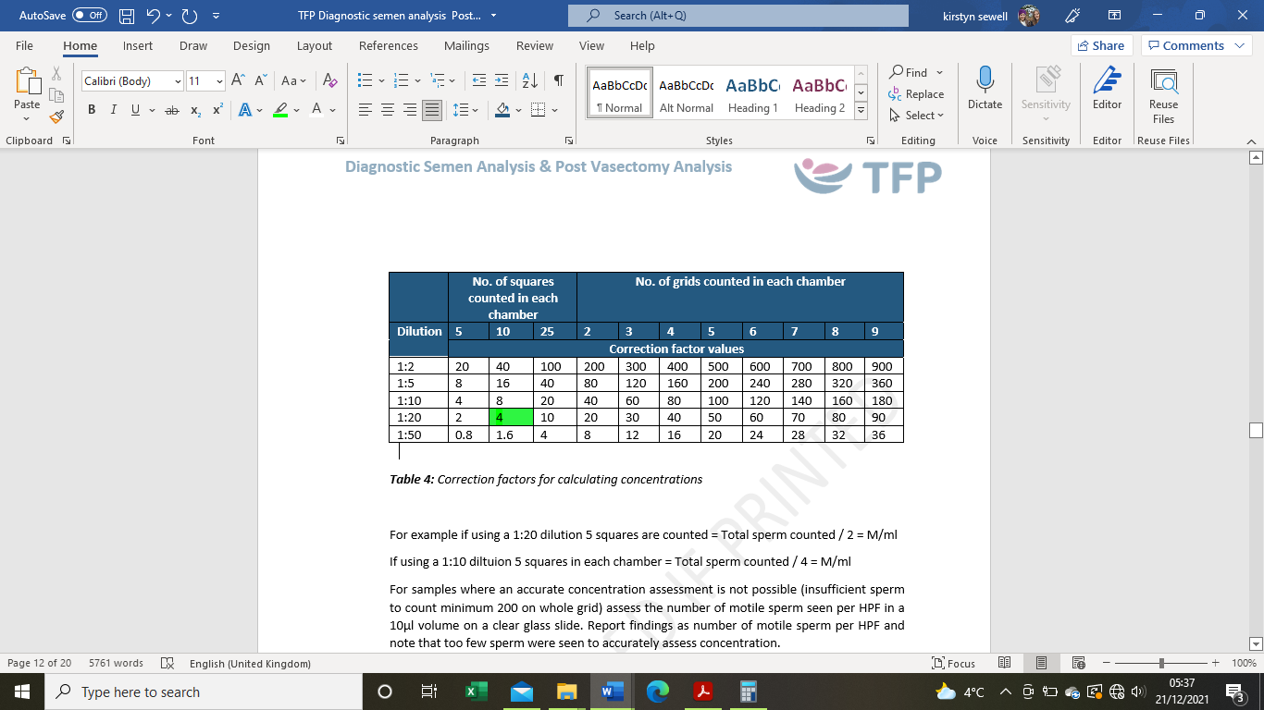
= Total number sperm counted/Correction factor
= 438/4
= 109.5M/ml

- Example 2 – a 1:5 dilution factor used (200µl water :50µl semen)
In replicate one 224 spermatozoa in 25 squares are counted, while replicate two contains 298 in 25 squares. The sum of the values (224 + 298) is 522 and the difference between the two replicates (298-224) is 74. From the table above this is seen to be more than that found by chance alone (44), so the values are rejected, and a new chamber must be made and recounted.
On the repeat assessment replicate one contains 224 spermatozoa in 25 squares, while replicate two contains 213 spermatozoa in 25 squares. The sum (224 + 213) is 437 and the difference (224-213) is 11. From the table above this is seen to be less than that found by chance alone (40), so the values are accepted.
A 1:5 dilution has been used and 25 squares have been counted on each side.
From the table above the correction factor for a 1:5 dilution and 25 squares counted in each chamber is 40.
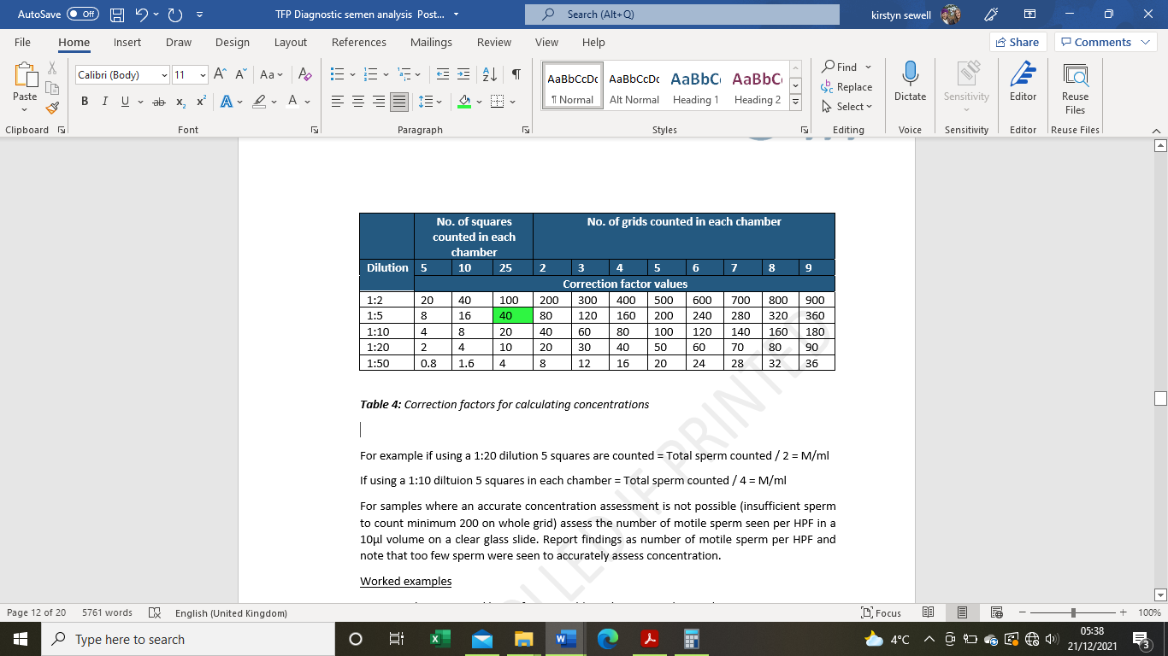
= Total number sperm counted/Correction factor
= 437/40
= 10.93M/ml

- Example 3 – a 1:2 dilution factor used (100µl water :100µl semen)
In replicate one 75 sperm are counted in the central grid, as 200 sperm have not been reached the next whole adjacent grid (grid 4) is counted. This yields 148 sperm therefore the whole of the next adjacent grid (grid 6) is counted. This gives 220 spermatozoa counted in 3 grids in replicate one, the same number of grids are counted in replicate two to give 218 sperm in 3 grids. The sum of the values (220 + 218) is 438 in 3 grids and the difference between the 2 replicates (220-218) is 2. This is seen to be less than that found by chance alone (acceptable difference = 41), so the values are accepted.
From the table above the correction factor for a 1:2 dilution and 3 grids counted in each chamber is 300.
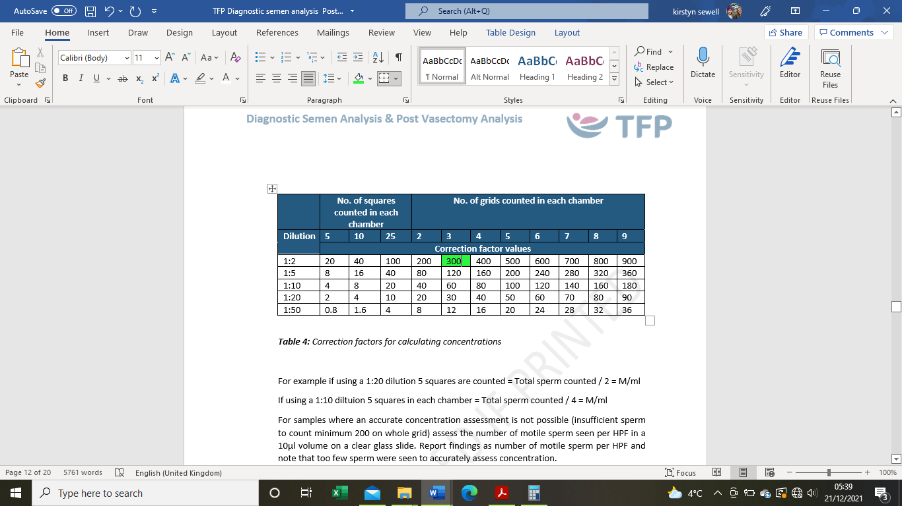
= Total number sperm counted/Correction factor
= 438/300
= 1.46M/ml

5.7.5 Calculation of Total Sperm Number (Reference value Total Sperm Number ≥39M)
The total sperm number should be reported for each sample. This is calculated by multiplying the concentration of sperm in millions per ml by the volume of the whole sample.

5.7.6 Assessment of Morphology (Reference value normal forms ≥4%)
Place 5µl of semen onto a pre-stained morphology slide and cover with a cover slip. Allow the slide to air dry for 15-30 minutes. Observe the slide at X1000 magnification under oil immersion. Grade 200 whole sperm as ‘normal’ or ‘abnormal’ according to WHO 2021 criteria. Note the result as a percentage of ‘normal’ forms.
The categories of the abnormalities (i.e. head, neck and mid-piece, tail and cytoplasmic residues) do not need to be specified in the report however operators should be able to categorise these (i.e. via participation in IQA and EQA).
For samples with low concentrations (<2M/ml) report that there are too few to accurately assess the morphology. Alternatively, the sample may be concentrated down by centrifugation prior to assessment. However, this should be reported in the report as centrifugation may affect the morphology result.
For sperm to be considered ‘normal’, both the tail and head must be normal. All borderline sperm must be considered ‘abnormal’.
Normal sperm have smooth, oval shaped head with a well-defined acrosomal area comprising 40-70% of the head area. The acrosomal area should not contain any large vacuoles and not more than two small vacuoles. There should be no vacuoles in the post acrosomal region.
The midpiece should be slender and regular and approximately the same length as the head. The axis of the midpiece should be aligned with the axis of the sperm head.
Cytoplasmic droplets should be < 1/3 of the size of the sperm head.
The tail should be regular and thinner than the midpiece and around ten times the length of the head (approximately 45µm long).
If prevalence of specific defects are noted in the assessment, such as sperm with heads lacking acrosomes (‘globozoospermia’) or ‘pinheads’ (free tails with no head structure), these should be reported.

5.7.7 Assessment of Anti-Sperm Antibodies IgG (Reference value <50%)
Allow the reagents to warm to room temperature.
Thoroughly mix the reagent(s). Add 5µl of each IgG reagent (latex beads and anti-serum to IgG) to a clear glass slide along with 5µl of semen. Mix on the slide using the pipette tip. Place a cover slip on top.
Allow the sample to settle for 3 minutes then observe the slide under x200-400 magnification.
Assess 200 motile sperm for the presence of beads bound to them. Convert the number of sperm showing evidence of binding to a percentage.
If initial assessment shows no binding, assess again after 10 minutes to confirm the result.

5.7.8 Assessment of pH (Reference Range pH ≥ 7.2)
Perform the pH assessment within 1 hour of sample production.
Place a drop of the semen sample on the pH paper. Wait for the colour of the impregnated zone to become uniform. Compare the colour to the calibration strip and read the pH.

5.7.9. Assessment of Viability, if motility <5%, (Reference value ≥ 54% live)
Perform the Vitality assessment within 1 hour of production, ideally at 30 minutes following liquefaction using Vitalscreen (Eosin and Nigrosin exclusion).
Mix 50µl of semen with 2 drops of reagent 1 in an Eppendorf tube, mixing gently, and after 30 seconds add 3 drops of reagent 2. Mix thoroughly. Within 30 seconds place a 20µl drop of mixture on to a clear glass slide and make a smear using the edge of a cover slip. Cover with a cover slip and assess immediately at X400. Alternatively assess the slide at X1000 magnification under oil immersion. Assess 200 sperm as unstained (live) or stained (dead), calculate the percentage viable (live).

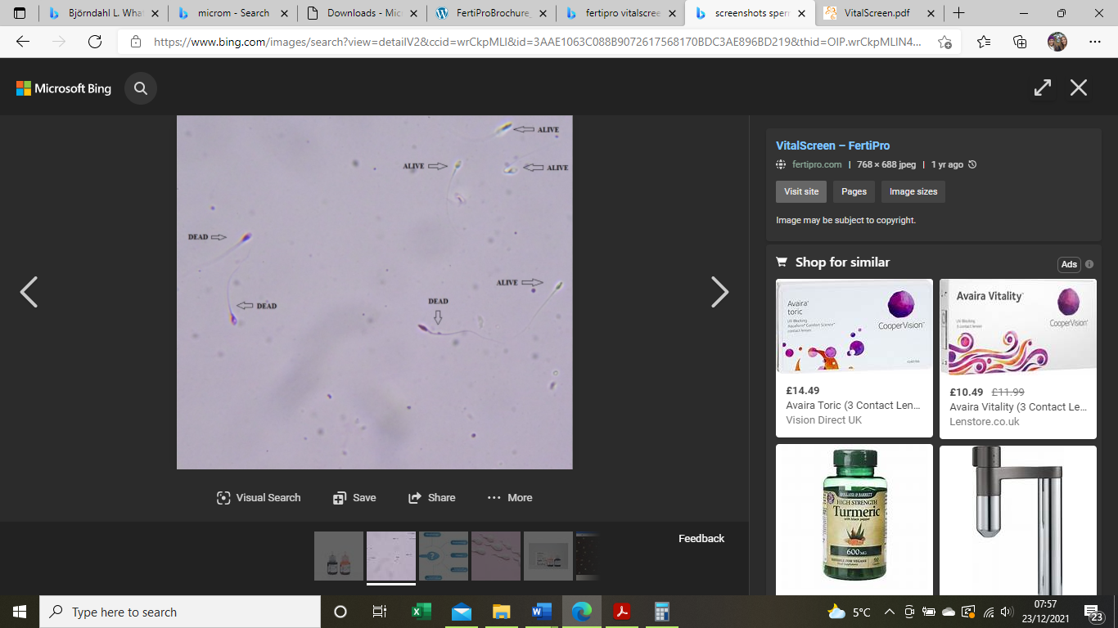
Image 4 – Example of stained (dead) (image 1) and unstained (live) sperm at X400 (image 2) Fertipro, 2019

Alternatively, the Hypo-Osmotic Swelling Test (HOS) may be used to distinguish between viable and non-viable non-motile sperm.

5.7.10 Assessment of Round Cells, if indicated (Reference value <1M/ml Peroxidase Positive Cells)
An assessment of round cells in the sample can be carried out in the same way as concentration as decsribed above using the haemocytometer chamber, using an appropriate dilution. If the round cell count is found to exceed 5M/ml, an assessment using LeucoScreen Plus should be performed to determine the concentration of peroxidase positive cells. Record the concentration of total positive round cells.
To perform a LeucoScreen assessment:
Prepare a working solution by adding 200µl Reagent 1, 5µl of Reagent 2 and 1ml of Reagent 3 to an Eppendorf tube and mixing thoroughly.
This working solution can be kept for 48 hours if protected from sunlight and stored at 2-8°C.
Mix 10 µl of sperm with 20 µl of working solution in an Eppendorf and mix thoroughly. Incubate for 2 minutes at room temperature in the dark.
Transfer 10µl of the mix to a glass slide and add 10µl of Reagent 4. Mix thoroughly using the pipette tip/edge of the coverslip.
Cover with a coverslip and assess the slide.
Observing at least 20 fields at X400 magnification, count and classify (peroxidase positive or peroxidase negative) a total of 200 round cells.

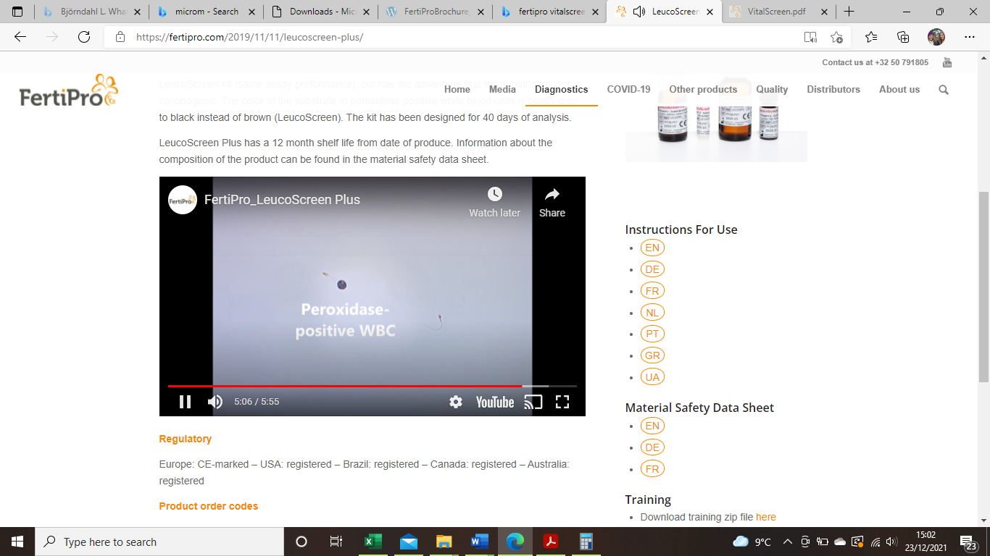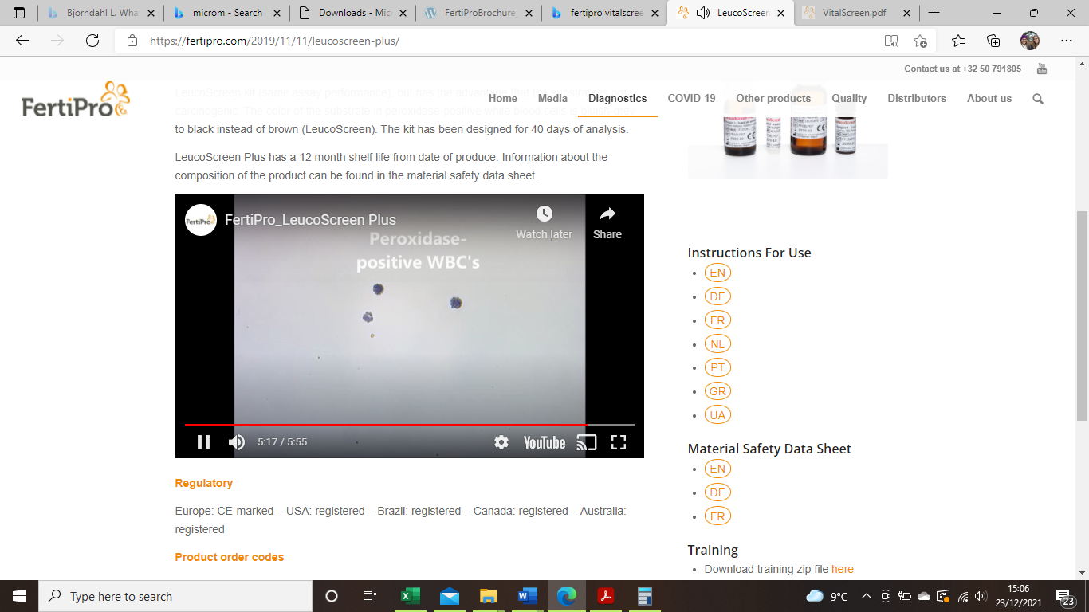
Image 5– Examples of Peroxidase positive white blood cells (Fertipro.com, 2019)

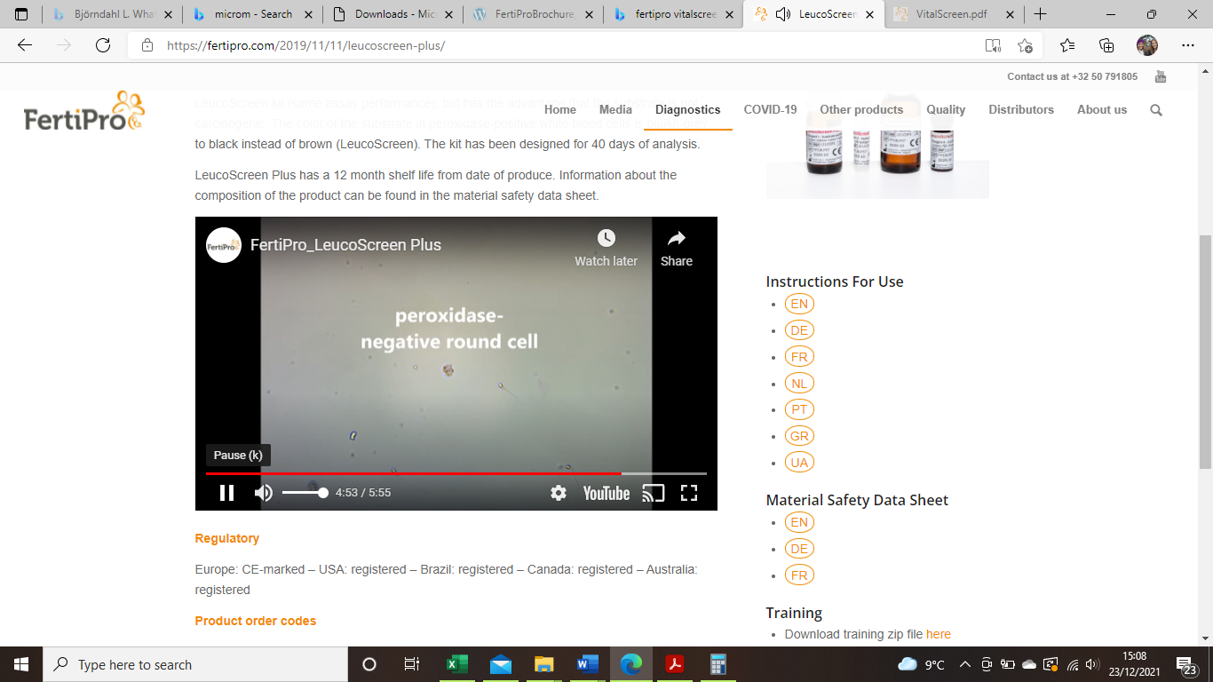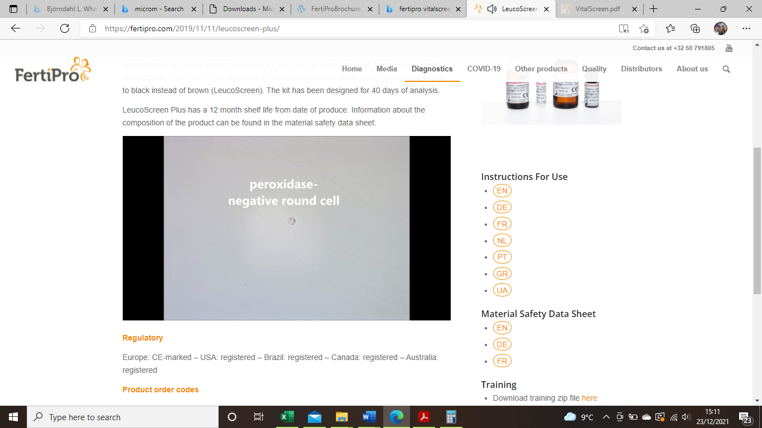
Image 6 - Examples of Peroxidase negative white blood cells (Fertipro.com, 2019)

Calculate the proportion of peroxidase positive cells based on the below formula:
Proportion of positive round cells = No. of positive round cells / (No. of positive and No. of negative round cells).
Then calculate the concentration of peroxidase-positive white blood cells in M/ml using the following formula:
Concentration of peroxidase positive white blood cells (M/ml) = Proportion of Positive round cells X total concentration of round cells
(where total concentration is the concentration of round cells as assessed above on haemocytometer).

5.7.11 Additional Microscopic Assessments (if indicated)
Agglutination (where motile sperm stick together i.e. head-to-head, tail-to-tail, tail tip-to-tail tip, or mixed) can be assessed and recorded if noticed to be high and a comment made on the report as agglutination ‘+ (<10 sperm per agglutinate), ++ (10-50 sperm per agglutinate), or +++ (agglutinates of >50 sperm). A note should be made on the report of the type of attachment.
If sperm aggregates (where immotile sperm stick together, stick to motile sperm or stick to mucus strands or debris) are noticed in the sample a note of this can be made on the report.
If debris or bacteria is noticed in the sperm sample, this can also be noted on the report as debris or bacteria ‘+, ++ or +++’.

5.7.12 Post Examination Procedure
Following completion of the semen analysis, clear the flowhood of any used consumables. Use Oosafe ± sterile water to clean the flowhood/bench.
Dispose of any used slides/pipettes/pots/tubes in clinical waste (sharps bins for sharp objects).
Proceed to writing the semen analysis report.

5.8 Low Sperm Numbers & Suspected Azoospermia
If too few sperm are seen on the haemocytometer chamber in 9 grids for an accurate assessment (<25 sperm in each whole chamber using a 1:2 dilution i.e. <55,555 sperm/ml), the number of sperm observed should be reported, however a note needs to be made on the report that too few sperm are seen for accurate assessment (<56,000).
Assess the number of sperm seen in the initial 10µl per HPF for the two replicates and whether sperm seen are motile/twitching/immotile.
If only immotile or twitching sperm are seen in the initial 10µl, samples may be concentrated to a smaller volume by centrifugation at 0.3-0.8rcf and then re-assessed for the presence of motile sperm.
If no sperm are seen in the initial 10µl slide, the sample should be assessed for the presence of sperm using either centrifugation method (2002 BAS guidelines) or fixed depth Post Vasectomy slides (2016 Guidelines). These processes are outlined in 5.11 below.
If no sperm are seen in the sample then a follow up appointment must be made in 2-3 months’ time in order to diagnose azoospermia.
At the end of the semen analysis, clear the flowhood/bench of any used consumables. Use Oosafe ± sterile water to clean the flowhood/bench.

5.9 Assessment of Motility and Concentration using CASA systems
CASA systems (Computer Aided Semen analysis) systems can be used as an alternative to manual methods to assess concentration and motility however they must be validated against a haemocytometer chamber.

5.9.1 SCA CASA (Microptics)
To be suitable for assessment via the CASA, samples should have a minimum of >15 sperm per X400 HPF.
If samples exceed >50M/ml they should be diluted 1:1, 1:2 or 1:3 with media prior to assessment, by mixing 50µl of semen with: 50µl, 100µl or 150µl of media (as required) in an Eppendorf tube. The dilution factor must be taken into account when assessing on the CASA, by selecting a dilution factor (as described below). A note should be made on the report of the dilution factor used.
Use a fixed depth (20µm) chamber suitable for use with the CASA system (such as a Leja 20 slide) and pipette 8-10 µl of semen into the chamber(s) of the slide.
Observe the filling time of the chamber and adjust the viscosity settings as required in the CASA settings.
<2-3s – low viscosity
4-10s – medium viscosity
>10s – high viscosity
Allow the slide to settle for around 2 minutes, and then place the slide onto the microscope. For analysis on the CASA, the slide should be observed under x100 magnification.
Open up the SCA program, then select ‘Programs’ from the top menu, and from the subsequent drop down list select ‘SCA motility’.
A message will appear on the screen: ‘Do you want to analyse without creating a sample in the database’. Click ‘yes’ unless the file is to be saved, then on the resulting screen select the required configuration (i.e. Human sperm analysis Leja 20), and select the ‘tick’ icon to proceed.
This will bring up the home page for the patient. On this tab the patient’s details can be entered in the ‘Patient’ box. If a dilution factor has been used the correct dilution should be selected from the ‘Dilution’ box by increasing as required, for example: 1 for a 1:1 dilution, 2 for a 1:2 dilution etc. Click ‘Analyse’ in the top left hand corner to begin the analysis.
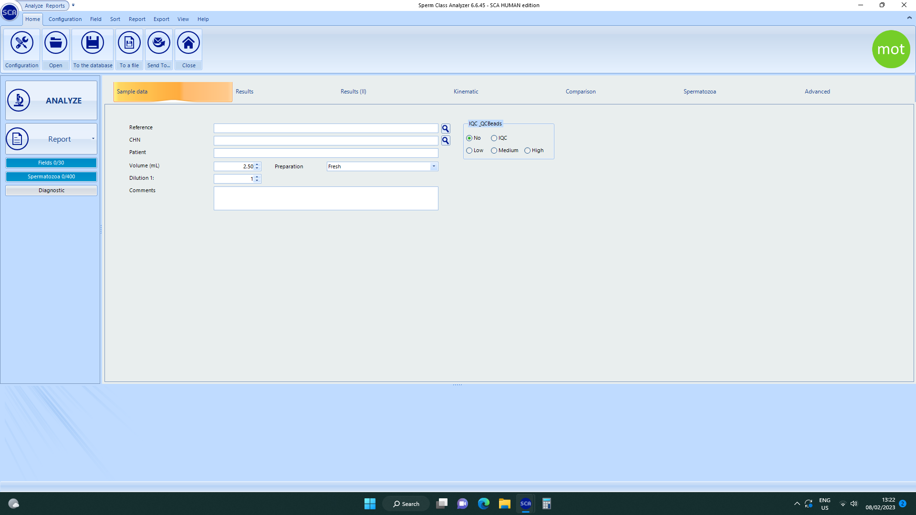

Image 7 – Patient home page on the SCA CASA

On the screen an image should appear of the field of view of the sample. Using the image shown on the CASA screen, select a suitable field of view on the microscope in the middle of the fixed depth chamber, for the system to capture an image. Focus the image using the microscope.
Click ‘Analyse’ in the top right-hand side of the screen to capture the image.
The CASA system will then capture an image of the field of view and will place identifiers (see image below) to identify any sperm and to grade them according to the 4 motility grades:

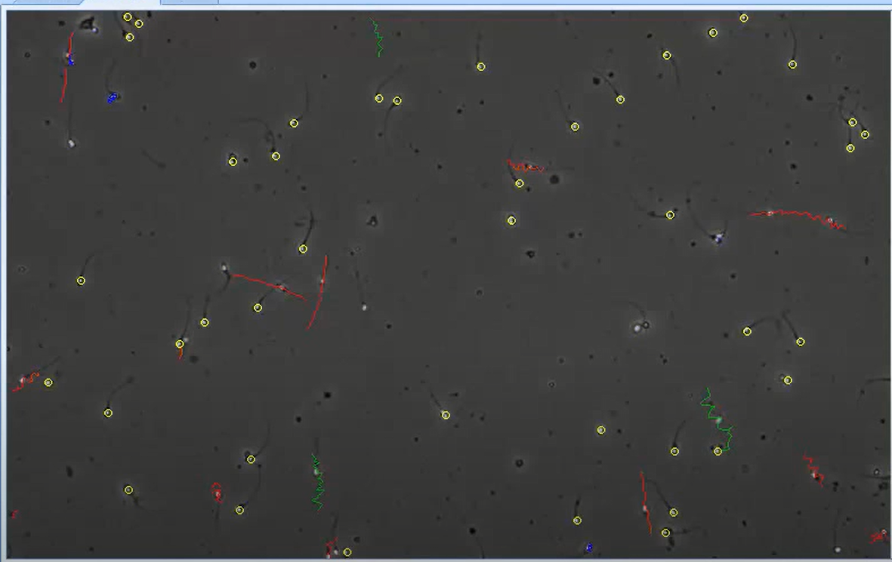
Image 8 – Example image using a CASA system (https://www.micropticsl.com)

Red (Grade A) - Rapid progressive motility (≥25µm/s)
Green (Grade B) - slow or sluggish motility (5 - <25 µm/s)
Blue (Grade C) – non-progressive motility (<5 µm/s)
Yellow (Grade D) – immotile (no active tail movement)
From this video capture the system will automatically calculate sperm concentration and motility values which can be seen on the right-hand side of the screen, along with the number of sperm that have been captured so far.
Repeat the process with further fields of view until a minimum of 400 sperm in a minimum of 3 fields of view have been assessed.
For samples where the concentration is <10M/ml, a minimum of 200 sperm must be assessed.
Once 400 sperm have been captured, a box will appear with the message: ‘Would you like to see the final results’. Click ‘No’ in order to review the videos before the final results are displayed, or if further fields of view are to be analysed.
In order to review the videos captured for each field of view, click on the ‘Analysis’ tab at the top of the screen. Click the arrows at the top of the screen ‘Previous’ or ‘Next’ as required to move from one field to the next.
For each field of view displayed, click the ‘Play’ icon on the right-hand side of the screen to replay the video capture which will show the motility of all the sperm captured.
To deselect any cells that have been inappropriately identified, for example incorrect motility grades, debris or non-sperm cells (NSCs), click the ‘X’ icon on the left hand side of the screen (see image 9 below) and remove the incorrect motility grade as required by clicking on the incorrectly graded sperm cell.
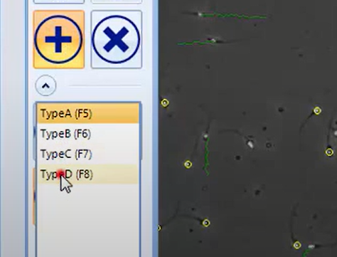
Image 9 – How to add/deselect sperm manually on the CASA (https://www.micropticsl.com)
To add a motility grade to any cell that has been missed or mis-identified click the ‘+’ icon, select the correct motility grade from the drop-down menu (see image 9 above), and then click on the sperm cell to add the grade to it. This can also be done by right clicking on a sperm cell and selecting the correct grade from the list that appears.
Repeat this process as required for all fields. Once all fields have been reviewed, click the results button.
This will bring up the results page which will display the final results for the concentration, total motility and each motility grade for the sample.
Record results and update records.
Clear the flowhood/bench of any used consumables. Use Oosafe ± sterile water to clean the flowhood/bench.
5.10 Retrograde Analysis
Retrograde samples must be produced on site so that the sample can be prepared as quickly as possible.
The patient is required to adjust the osmolality and pH of their urine prior to sperm production.
Advise the patient to take 2 Alka-Seltzer tablets or a 20ml Potassium Citrate mixture the night before producing the sample and again 2-4 hours prior to sample production.
On the morning of sample production ask the patient to avoid caffeine/fruit juice and drink approximately 500ml of water.
Immediately prior to sample production the patient must empty their bladder. Sample production must follow immediately afterwards.
Advise the patient to collect any ejaculate produced into the semen pot and then empty their bladder and collect the urine into the sterile jug provided.

Both semen and urine samples must be passed to the laboratory for immediate analysis.

If an adequate number of motile sperm for analysis are in the semen sample, proceed with analysing the semen sample alone.

If no sperm or an inadequate number are found in the semen sample proceed with processing the urine sample. Determine the pH of the urine sample.

Transfer the urine to pre-labelled conical tubes and centrifuge at 0.8 r.c.f. for 5 minutes.

Remove the pellet and re-suspend in 0.5ml of pre-equilibrated media. Assess the suspension for the presence of sperm. Report if any sperm are seen in the urine. Concentration, motility and morphology assessments as described above should be performed.
Clear the flowhood/bench of any used consumables. Use Oosafe ± sterile water to clean the flowhood/bench.

5.11 Reporting & Interpreting the Results
Report the results of each test performed in the patient management system (a paper copy of the report may also be produced).
Interpretation of semen analysis results should only be done by members of staff deemed competent to do so.
Interpretation should consider guidance as set out in WHO 2021. The lower fifth percentile of men (the level under which only semen parameters from 5% of the men in the reference population were found to achieve a pregnancy within 1 year of trying (TTC <1 year) as per the WHO 2021) may be used as a guide when interpreting results, however it shouldn’t be used as a limit between fertile and infertile men.
Interpretation should also take in to account the patient’s clinical history and previous results. A single semen sample may not be representative and therefore it may be beneficial to request a further analysis.
For patients undergoing fertility treatment, treatment recommendations based on the sample should take into account reference values for the lower fifth percentile values as per WHO (2021) and recommendations made by referring to TFP1-POL-EMB-0001.
Recommendations may also be made regarding further options ie. Sperm freezing, SSR and donor sperm back up.

5.12 Post Vasectomy Analysis
Patients who have had a vasectomy will be given a post vasectomy semen assessment appointment to assess the presence of sperm in the sample. Clearance can be provided following the analysis of a single sample providing the strict criteria described below have been met. If the strict criteria below have not been met, a second sample must be requested.
Patients are advised to have their initial post vasectomy analysis a minimum of 12 weeks post vasectomy and after a minimum of 20 ejaculates.
The abstinence period should be 2-7 days for post vasectomy assessment for clearance to be given.
Incomplete samples for Post Vasectomy analysis must be rejected and a further appointment made for the patient.
Post vasectomy samples must be examined for the presence of sperm within 4 hours of production, however, it is recommended that samples are examined within 1 hour, because if non-motile sperm are observed then a further sample must then be analysed within 1 hour of production.
Provided the sample has been assessed within the recommended time period, and that sample collection criteria and lab procedures have been met and are strictly followed, one clear sample is sufficient for clearance.
However, a second sample to determine clearance can be carried out on request from the referrer or as per local policy.
Patients are advised to have any repeat appointments a minimum of 4-6 weeks after their initial assessment.
Patients that have continued immotile sperm seen in the sample after 7 months post-surgery may be given special clearance at the discretion of the clinic/referrer.
Special clearance must only be given if <100,000/ml non motile sperm are observed and after assessment of a minimum of 2 samples. It must not be given if any motile sperm are observed.

5.12.1 Initial Assessment
Record the volume and pH of the sample as described above.
With a serological/Pasteur pipette thoroughly mix the sample and place 10µl of semen onto a clear glass slide and cover with a glass cover slip. Observe the slide at X200-400 magnification for the presence of sperm.
Record if any sperm are seen in the wet preparation, then report of the approximate number of sperm seen on the wet preparation per HPF and if the sperm seen were motile, twitching or immotile.
If numbers of sperm seen exceed >1M/ml carry out a full semen analysis.
If no sperm is seen in the initial 10µl, the sample must be assessed by either method below:

5.12.2 Option 1: Assessment on Deep Chamber 100um PVSA slide (2016 guidelines)
Transfer 25µl of sample into a fixed-depth 100µm post vasectomy slide. The filled slide should then be stored in a humid atmosphere for a minimum of 15 minutes prior to examination.
Examine the slide for the presence of sperm on a phase contrast microscope under x200 magnification. The entire slide must be examined for the presence of sperm.
If sperm are seen, make a note of the number of sperm seen in the PVSA slide on the report and report whether the sperm seen were motile.
If no sperm are seen, report that no sperm were seen in the fixed 100µm depth post vasectomy slides.

5.12.3 Option 2: Centrifuge Sample (2002 BAS Guidelines)
Transfer 1ml of sample into a tube/Eppendorf and centrifuge at 3.0 r.c.f. for 15 minutes.
Remove the supernatant and resuspend the pellet in a volume of 50µl.
Place two 10µl drops into a lake dish, overlay with oil and assess the drops on an inverted microscope for the presence of sperm.
If sperm is seen, make a note of this on the report and report whether the sperm seen were motile.
If no sperm are seen, report that no sperm were seen in the pellet post centrifugation.
Clear the flowhood of any used consumables. Use Oosafe ± sterile water to clean the flowhood.

6 Standards/Key Performance/Quality Indicators
Each clinic must participate in an external quality assurance scheme for assessment of sperm concentration, motility and morphology with ‘Satisfactory’ performance.

7 Monitoring
A TFP laboratory manager is responsible for auditing this SOP at least once annually.

